Kinneret Retreat Schedule | 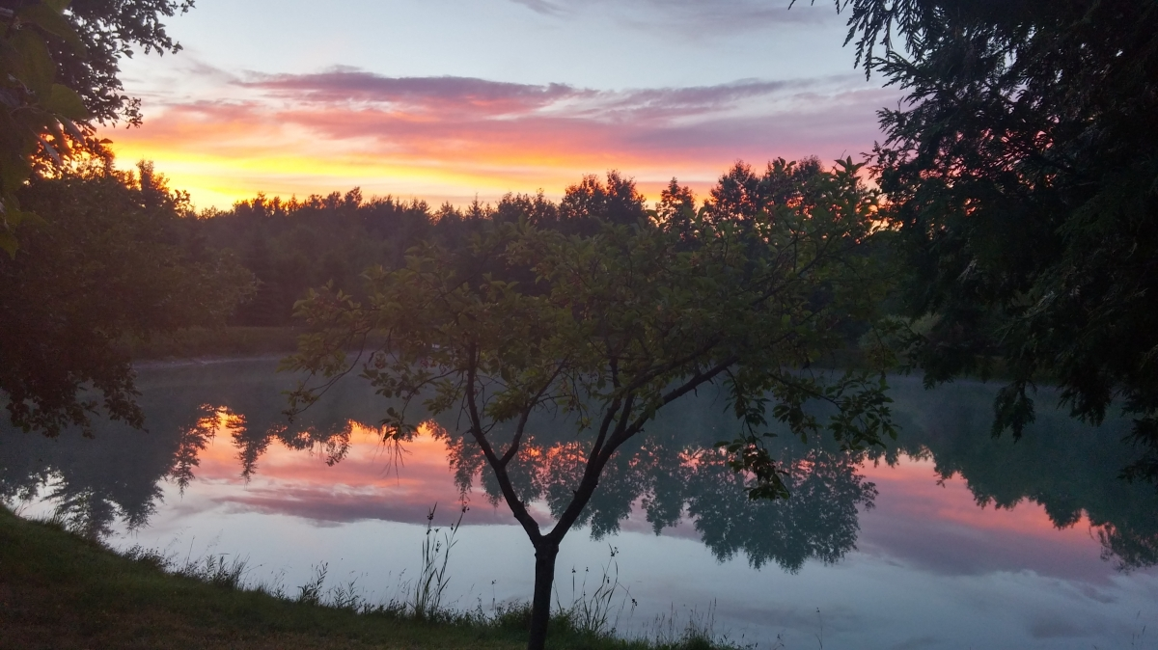
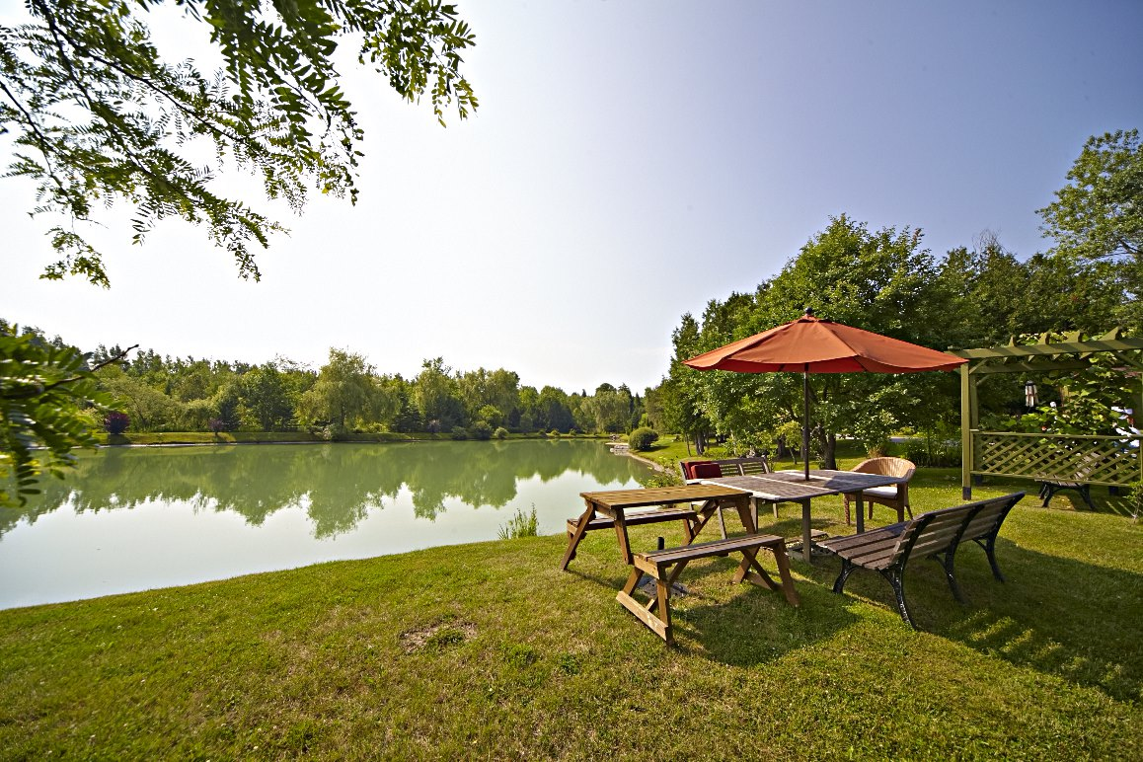 | 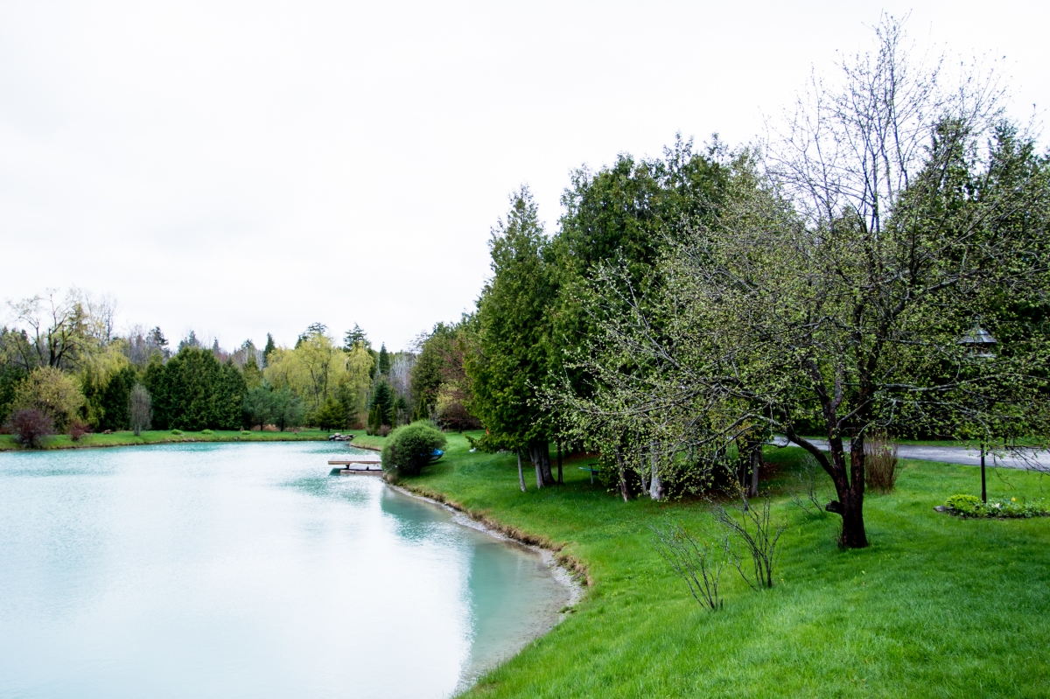

August 20th & 21st Schedule 2019: Schedule is the same for both days but content of workshops will differ
- Note you are not required to attend all workshops but can choose the one’s you wish to participate in
Note that the retreat ends on July 21st with dinner from 6-7:30 pm
Participants for 10 am yoga class must arrive on time (i.e. if people arrive to retreat center later than 10 am they will not be able to attend the 10 am class)
9-10 am : Arrive
10-11 am: Swim in the blue clay lined artesan pond , Take a Lesson on How to Paddle Board , paddle boat or do Beginners Yang/Yin Yoga
Gentle Stretch Move & Breath Practice with Kinneret

11 am-12 pm : Comedy Imve Workshop: Stepping Out of

Your Comfort Zone in Comfort

12:30 pm-1:30 pm: Lunch & Dine

1:30 pm-2:30 pm: Free Time , Swim, Boat, or Take a Lesson on How to Paddle Board
3 pm-4:15 pm: Swim , Boat, Or Intermediate Vinyasa Inspired Yoga Class with Kinneret

4:30 pm- 5 :30 pm: Guided hike, Swim, or Paddle boats/board
4:30 pm-5:30 pm: Swim/Boat or Full Body Movement Class with Sara **** Intermediate Level
6
6 p

11-12:15 pm: Comedy Improve Workshop: Step Out of Your Comfort Zone in Comfort Or Swim in Pond or Go for a Hike
12-1 pm : Lunch
1 pm -2:30 pm: Free Time or Paddle Board/Paddle Boat or Swim
2:30 pm-4:30 pm: Danspiration Dance Fitness Class with Leah
4:30 pm-5:30 pm: Free Time OR Yoga (4 low mobility students)
5:30 pm-6:30 pm : Intermediate Level Alignment Vinyasa Yoga with Kinneret
7 pm-8 pm : Dinner (note on Wedneday the retreat ends after dinner
8:30 pm-9:45 pm: * Note this Class is Only For Tuesday Evening* Learn About Personality Through Body Psychology (with Kinneret)

