Room Layout & Costs – Kinneret Retreat
Check out the website for the new location:
http://nirvanaretreats.ca/photo-gallery/
drive is approx. 1 hour

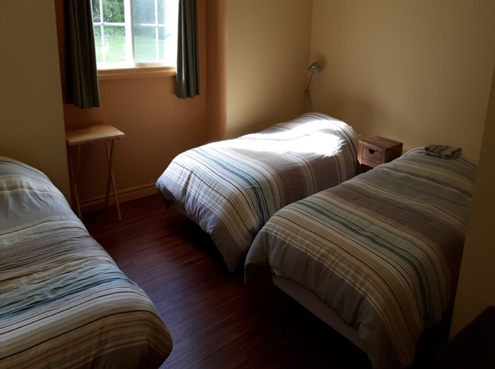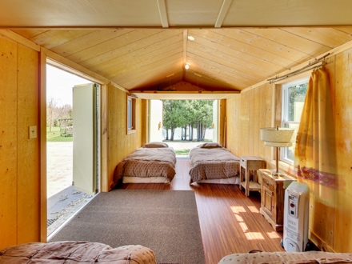

2 Locations for Rooms: Main House and Cabins * Photos of Actual Rooms Above
*Note : these rooms are for participants who wish to sleep the night
- Priority will be given to those participants who stay for both days of the retreat
- If there are rooms left, some participants staying only one day may have access to sleeping over
For Room Costs & Room Layout - Scroll down
For Room Costs: Note we do not offer private rooms

Nirvana Retreat has:
- 4 rooms in the main house – 3 beds per room (accommodates 12 people)
2 Bathrooms/Showers in the main house
- 2 additional cabins-4 beds per room ( accommodates 8 people)
2 Bathrooms / 1 Shower for cabins is in the Yoga Studio right near to the cabins

$65 per person (including tax) single bed in a shared room (4 beds per room)
$90 per person (including tax ) single bed in shared room (2 beds per room)- depends on availability

