Kinneret Retreat Schedule | 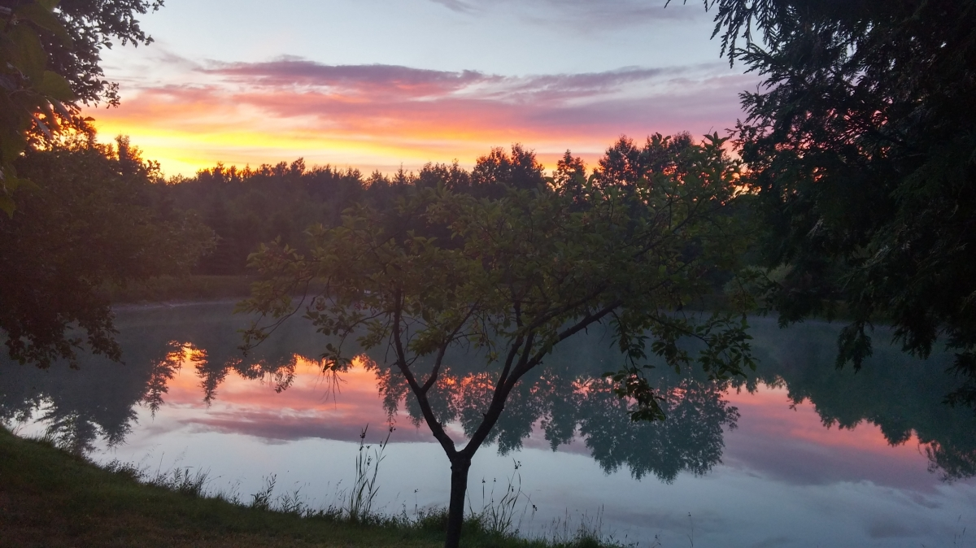
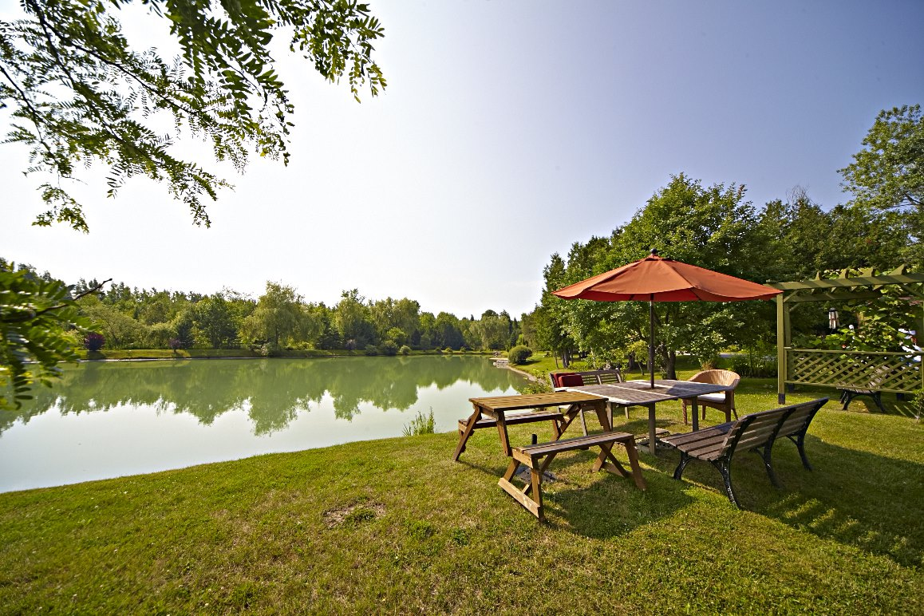 | 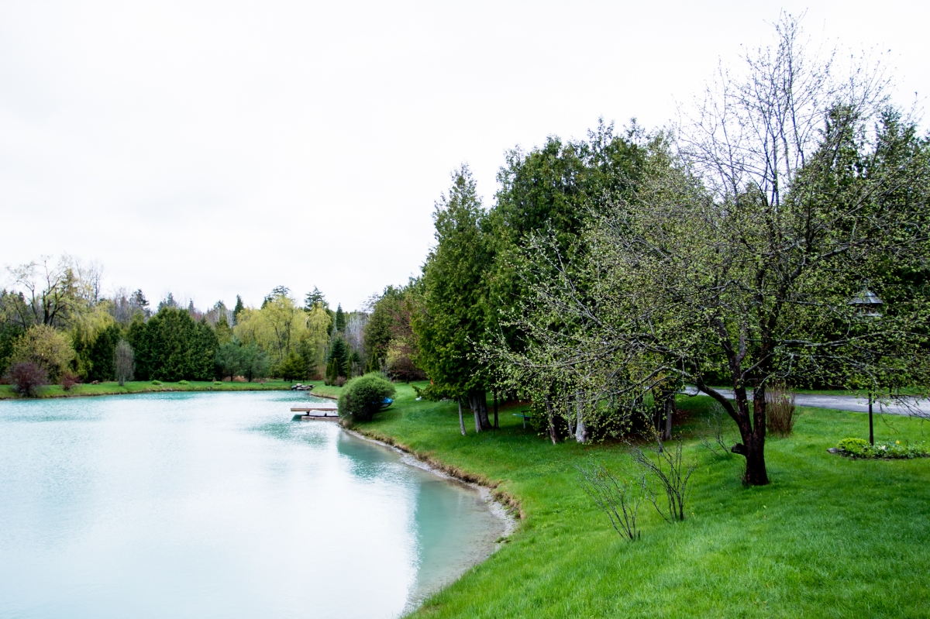

July 2^{nd & 3rd} Schedule 2019:
Note that the retreat ends on July 3rd with dinner from 6-7:30 pm
Participants for 10 am yoga class must arrive on time (i.e. if people arrive to retreat center later than 10 am they will not be able to attend the 10 am class)
9-10 am : Arrive
10-11 am: Swim in the blue clay lined artesan pond , Take a Lesson on How to Paddle Board , paddle boat or do a
Gentle Stretch Move & Breath Practice with Kinneret
11 am-12 pm Krav Maga Class : Intro to Self Defense
12:30 pm-1:30 pm: Lunch & Dine

1:30 pm-2:30 pm: Free Time , Swim, Boat, or Take a Lesson on How to Paddle Board
3 pm-4:15 pm: Swim , Boat, Or Intermediate Vinyasa Inspired Yoga Class with Kinneret

4:30 pm- 5 :30 pm: Guided hike, Swim, or Paddle boats/board
4:30 pm-5:30 pm: Swim/Boat or Full Body Movement Class with Sara **** Intermediate Level
6
6 p

1:30 pm -2:30 pm: Free Time
2:30 pm-4:30 pm: Vinyasa Inspired Intermediate Level Yoga Class followed by a 1 hour boxing fitness class
4:30 pm-5:30 pm : Yang Yin Yoga with Kinneret
6 pm-7:30 pm : Dinner
Those Participants Sleeping The Night July 1st:
8 pm (only for Tuesday night schedule) :
Outdoor Bon Fire or just relax and chill out
Breakfast on July 3rd will be served between 8-10 am

